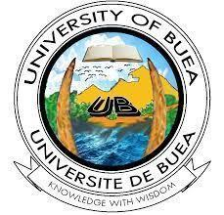

**FACULTY OF ENGINEERING**

**FACULTY OF ENGINEERING AND TECHNOLOGY**

**DEPARTMENT OF COMPUTER ENGINEERING, SE**

**CEF440: Internet and Mobile Programming**



**Presented by:**

| BOBGALA HARRISON DIMA | FE21A151 |
| --- | --- |
| KAMCHE YANN ARNAUD | **FE21A208** |
| MESSI II INNOCENT ROSTAND | **FE21A236** |
| NYANDO ONONGWENE | **FE21A290** |
| NKWI CYRIL AKINIMBOM | **FE21A281** |





**Table of Content**

**1. Objectives 2**

**2. Stakeholders 3**

**3. Methods Used and Data Gathered 5**

**3.1. Brainstorming 5**

**3.2. Interviews 6**

**Key Questions Asked: 6**

**3.3. Questionnaires 7**

Response 1: 8

Response 2: 14

Response 3: 22

**3.4. Research 29**

# 

# **Objectives**

* **Identify Your Target Audience:**

Identifying your target audience is crucial in disaster management as it helps tailor your response strategies to specific demographics, locations, or vulnerabilities. For instance, in planning for a hurricane, your target audience might include residents in coastal areas, emergency responders, government agencies, and vulnerable populations such as the elderly or those with disabilities. By understanding who you are serving, you can better anticipate their needs and design effective communication channels and support systems.

Consider a scenario where a city is prone to flooding due to heavy rainfall. In this case, the target audience could encompass residents in flood-prone neighborhoods, businesses located in low-lying areas, schools, hospitals, and municipal authorities responsible for disaster response. Each group may have distinct needs, such as access to evacuation routes, emergency shelters, medical assistance, or communication tools. By identifying these stakeholders upfront, disaster management teams can allocate resources efficiently and implement measures tailored to each group's requirements.

* **Understand User Needs:**

Understanding the needs of various stakeholders is essential for effective disaster management. This involves conducting thorough research, engaging with communities, and gathering feedback to identify priorities and preferences. For example, in the aftermath of an earthquake, residents may require immediate access to food, water, shelter, and medical assistance. Emergency responders might need clear communication channels, updated maps of affected areas, and specialised equipment to conduct search and rescue operations.

In another scenario, during a wildfire, the needs of rural communities might differ from those in urban areas. Rural residents may rely heavily on livestock or agricultural resources for their livelihoods, requiring assistance with evacuation planning for animals and preserving farmland. Urban dwellers, on the other hand, might prioritise information on air quality, transportation routes, and temporary housing options. By understanding these diverse needs, disaster management teams can develop comprehensive plans that address the specific challenges faced by different user groups.

* **Clarify Stakeholders' Expectations:**

Clarifying stakeholders' expectations is essential for aligning disaster management efforts with broader goals and objectives. This involves engaging with key stakeholders, including government agencies, non-profit organisations, community leaders, and the general public, to define roles, responsibilities, and desired outcomes. For instance, in preparing for a pandemic, stakeholders may expect clear guidelines on social distancing measures, access to testing and healthcare services, and support for vulnerable populations.

In a coastal community vulnerable to hurricanes, stakeholders' expectations may revolve around early warning systems, evacuation protocols, infrastructure resilience, and post-disaster recovery efforts. By engaging stakeholders through town hall meetings, surveys, or focus groups, disaster management teams can ensure that their plans are informed by local knowledge and reflect the priorities of those most affected. Additionally, regular communication and transparency help manage expectations during emergencies, fostering trust and cooperation among stakeholders as they work together to mitigate risks and build resilience.

# **Stakeholders**

* **Emergency Responders:**

Emergency responders play a critical role in mitigating the impact of disasters and saving lives. Their needs often include access to timely and accurate information, specialized equipment, training, and coordination with other agencies. For example, firefighters responding to a wildfire require up-to-date maps of affected areas, communication systems to coordinate efforts, and protective gear to ensure their safety.

Additionally, emergency responders may expect support from technology providers for tools such as GIS (Geographic Information Systems) mapping software or communication devices that enhance situational awareness and facilitate real-time decision-making. Collaboration with NGOs and humanitarian organizations can provide supplementary resources such as medical supplies, shelter assistance, and psychological support for responders working in high-stress environments.

* **Community Members of Localities:**

Community members are directly impacted by disasters and often have unique needs and expectations based on their demographics, geographic location, and socio-economic status. Their expectations may include clear communication channels for receiving alerts and updates, access to evacuation routes and emergency shelters, and assistance with recovery efforts.

For example, residents in flood-prone areas may expect proactive measures such as early warning systems, sandbag distribution, and assistance with flood insurance claims. By engaging with local communities through outreach programs, town hall meetings, and community forums, disaster management teams can gain insights into residents' concerns and preferences, fostering a sense of ownership and resilience within the community.

* **Technology Providers:**

Technology providers play a crucial role in disaster management by offering innovative solutions for communication, data analysis, and decision support. Their expertise can enhance the effectiveness of response efforts by providing tools such as mobile apps for emergency alerts, drone technology for aerial reconnaissance, or cloud-based platforms for data storage and analysis.

Technology providers may expect collaboration with government agencies and NGOs to ensure interoperability and compatibility of systems, as well as opportunities to pilot new technologies in real-world scenarios. By partnering with broadcast stations, technology providers can also amplify the reach of emergency messages and warnings, leveraging radio, television, and social media platforms to disseminate critical information to the public.

* **Broadcast Stations:**

Broadcast stations play a vital role in disseminating timely and accurate information to the public before, during, and after disasters. Their expectations may include access to official updates from government agencies, coordination with emergency management officials, and protocols for broadcasting emergency alerts and evacuation orders.

Broadcast stations may expect support from technology providers to enhance their capabilities for emergency broadcasting, such as integrating alerting systems into their broadcasting infrastructure or providing training on crisis communication best practices. Collaboration with NGOs and humanitarian organizations can also facilitate public awareness campaigns, community outreach efforts, and fundraising initiatives to support disaster response and recovery efforts.

* **NGOs and Humanitarian Organizations:**

NGOs and humanitarian organizations provide essential support in disaster management through their expertise in humanitarian assistance, logistics, and resource mobilization. Their expectations may include coordination with government agencies and emergency responders, access to funding and resources, and opportunities for capacity building and training.

NGOs and humanitarian organizations may expect collaboration with technology providers to leverage innovative solutions such as mobile apps for volunteer coordination, crowd-sourced mapping platforms for damage assessment, or blockchain technology for transparent aid distribution. By engaging with local communities and community-based organizations, NGOs and humanitarian organizations can ensure that their interventions are contextually relevant and responsive to the needs of those affected by disasters.

# **Methods Used and Data Gathered**

## **Brainstorming**

1. **User Needs and Expectations**

Below are ideas gathered as far as user needs and expectations are concerned:

* Narrow down the application to focus on a particular nation. Cameroon was the best option.
* Signalling of individuals in case of any disaster in progress.
* Sensitization on the various disasters and how to not be a victim. This would be a ‘preparedness’ measure. Notifications and messages could be used to let the general public know.
* Make users know about the weather conditions in their location.

1. **Scenario-based Ideas**

Here we talk about what could be done in order to respond to an occurring disaster.

* Social media broadcast
* Best routes to take to get to safe zones.
* Communicate with family members.

1. **Location-based Ideas**

Here we ideated on our current environment and situation.

* Floods and Fires are the most common in Cameroon.
* Not everyone uses a smartphone.

## **Interviews**

The requirement gathering phase for a disaster management system involves engaging with various stakeholders to understand their needs, challenges, and expectations. Here, we summarize the insights gathered through interviews with different groups, including disaster survivors, researchers, and individuals who haven't experienced disasters.

Interviews were conducted with the following groups:

**1. Disaster Survivors:** Individuals who have experienced natural or man-made disasters firsthand, offering unique perspectives on challenges faced and requirements for effective disaster management.

**2. Researchers:** Experts in disaster management and related fields, providing insights based on scholarly research, best practices, and theoretical frameworks.

**3. Individuals Without Disaster Experience:** Representing the general population, these individuals offer perspectives on preparedness, awareness, and the potential impact of a disaster on their lives.

### Key Questions Asked:

**1. Disaster Survivors:**

- Can you describe your experience during the disaster event?

- What were the most significant challenges you faced in terms of communication, access to resources, and coordination?

- How did you receive information and alerts about the disaster?

- What functionalities do you think would have been helpful in managing the situation more effectively?

- What support mechanisms were most beneficial to you during the recovery phase?

**2. Researchers:**

- Based on your expertise, what are the key factors contributing to effective disaster management?

- What emerging technologies or methodologies show promise in improving disaster response and recovery efforts?

- From your research, what are the common challenges faced by stakeholders involved in disaster management?

- Are there any specific requirements or best practices that should be considered in the design of a disaster management system?

**3. Individuals Without Disaster Experience:**

- How would you rate your level of preparedness for a potential disaster?

- What sources do you rely on for information and updates during emergency situations?

- What features or functionalities would you expect from a disaster management system to help you better prepare for and respond to disasters?

- In your opinion, what role should technology play in improving disaster preparedness and response efforts?

## **Questionnaires**

In order to better understand the needs and expectations of our potential users, we made a questionnaire via Google Forms and shared it to the general public to get their views on what they would expect from a mobile-based disaster management system.

We asked questions to get the respondent’s personal and geographic information, their past experiences in disasters and emergency situations if any, the challenges they faced and what they think will be important or necessary to know and have in the situation of an emergency. In this section, some of the responses will be reviewed.

### Response 1:

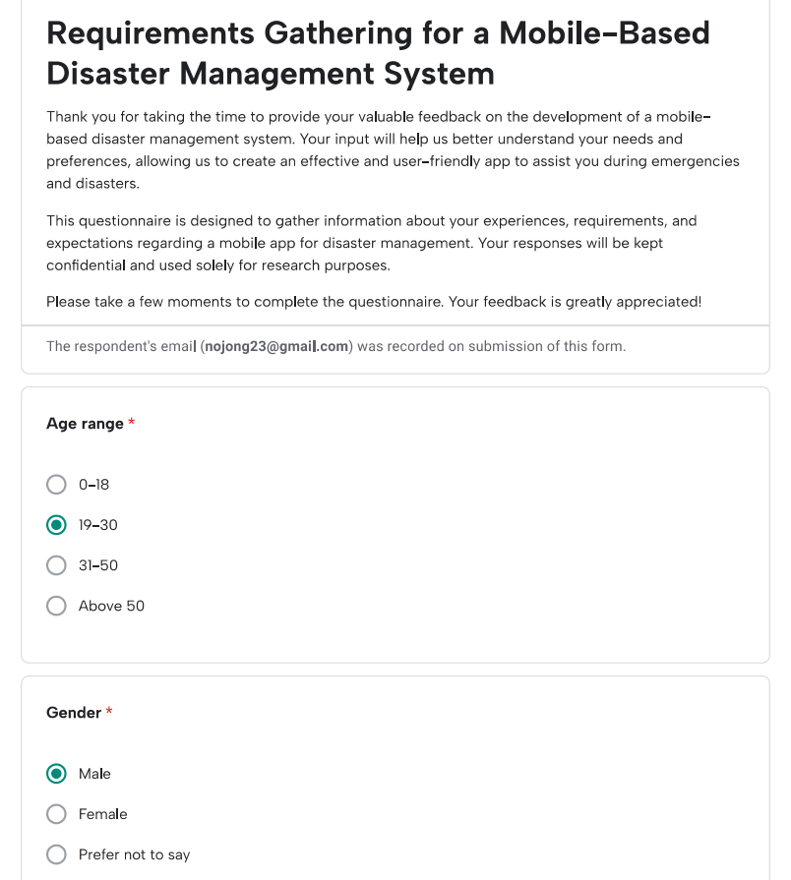

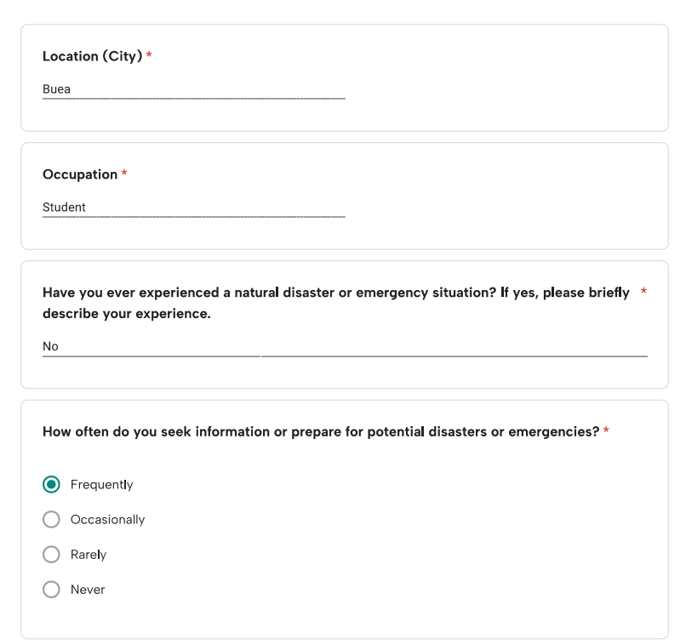

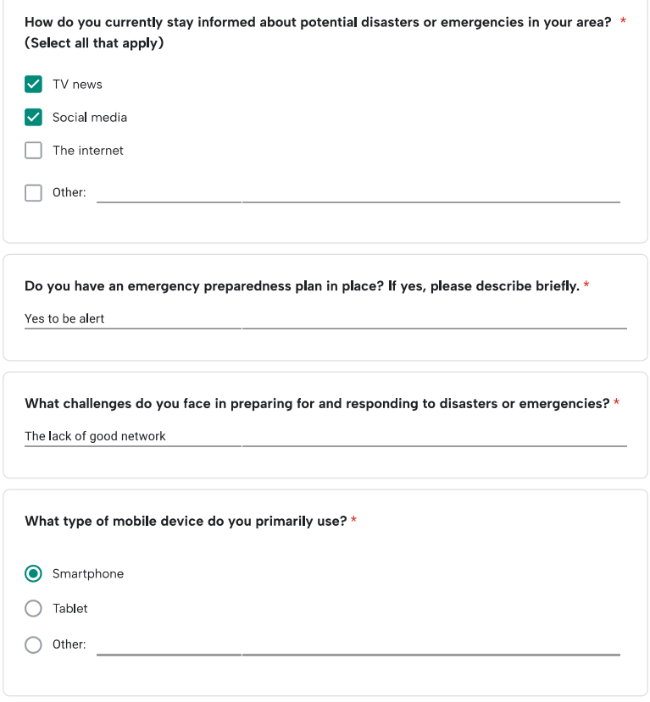

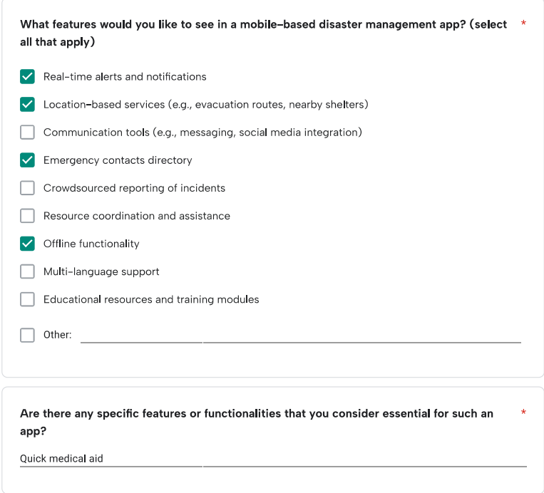

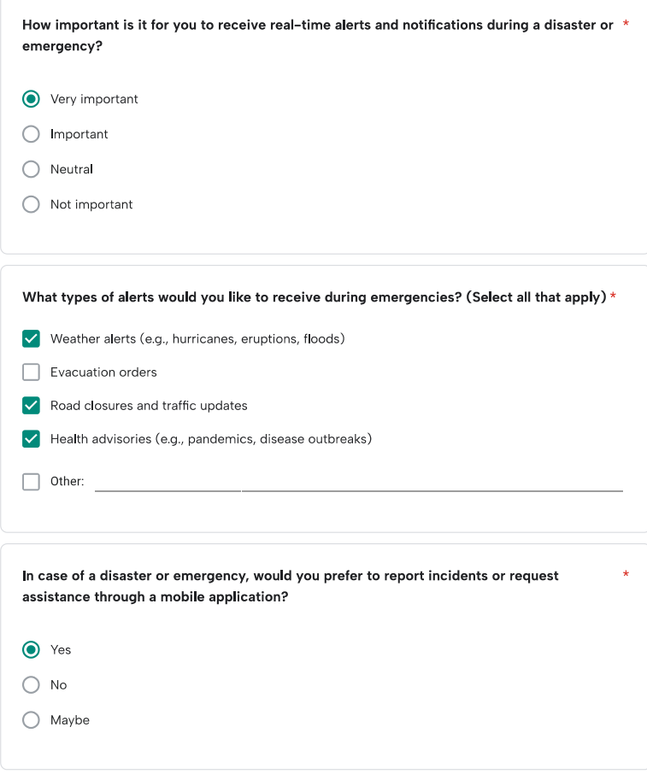

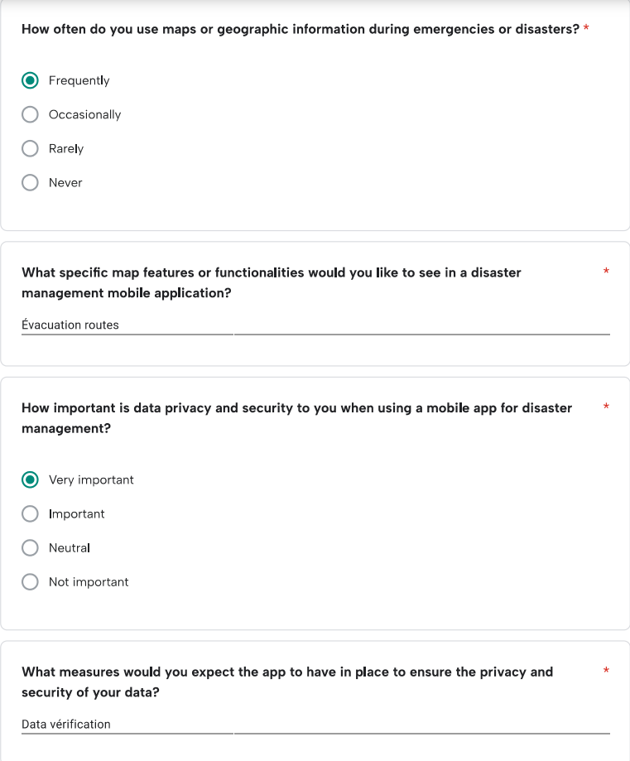

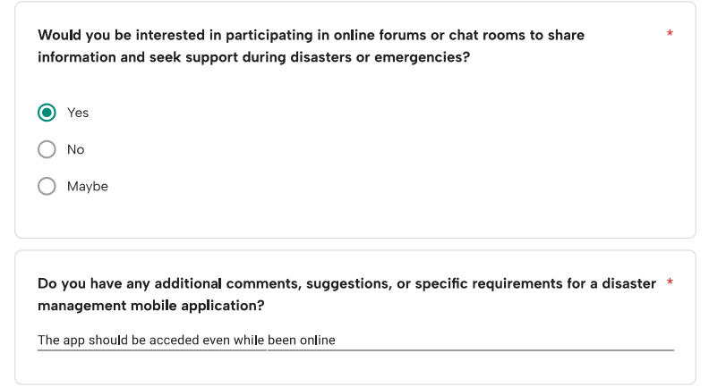

### Response 2:

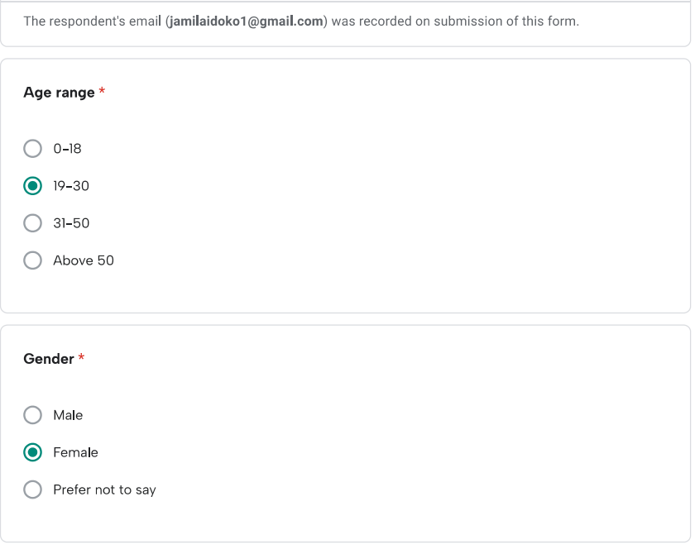

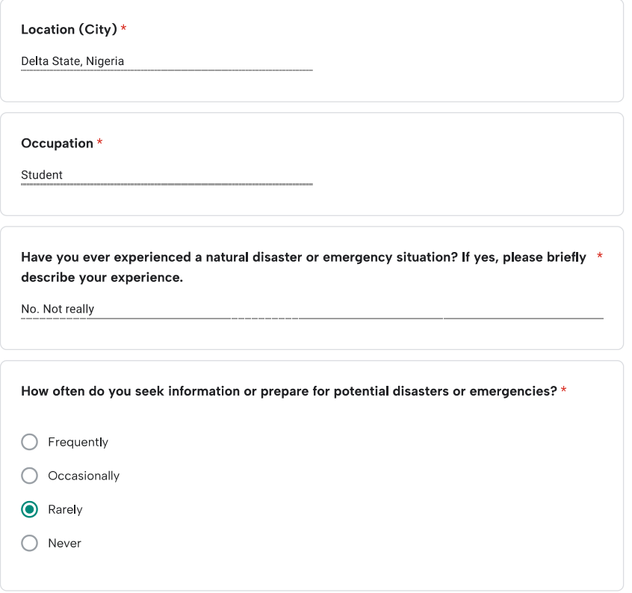

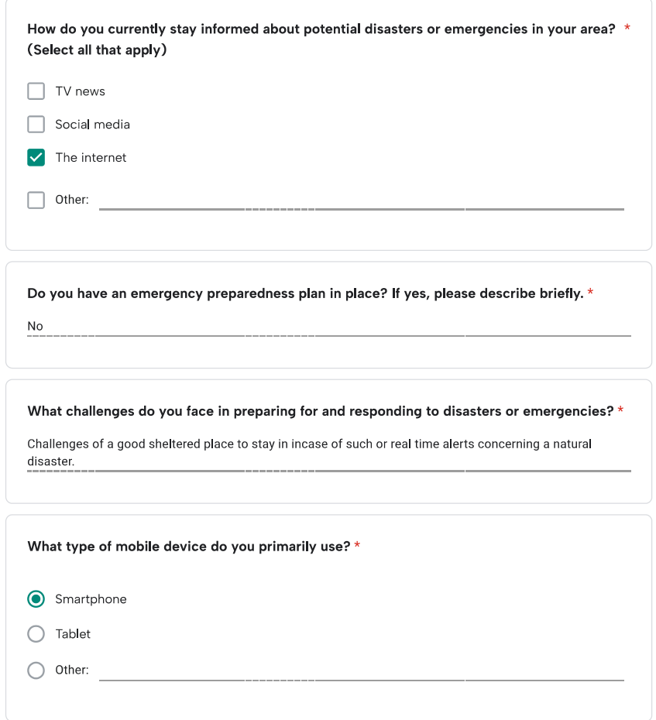

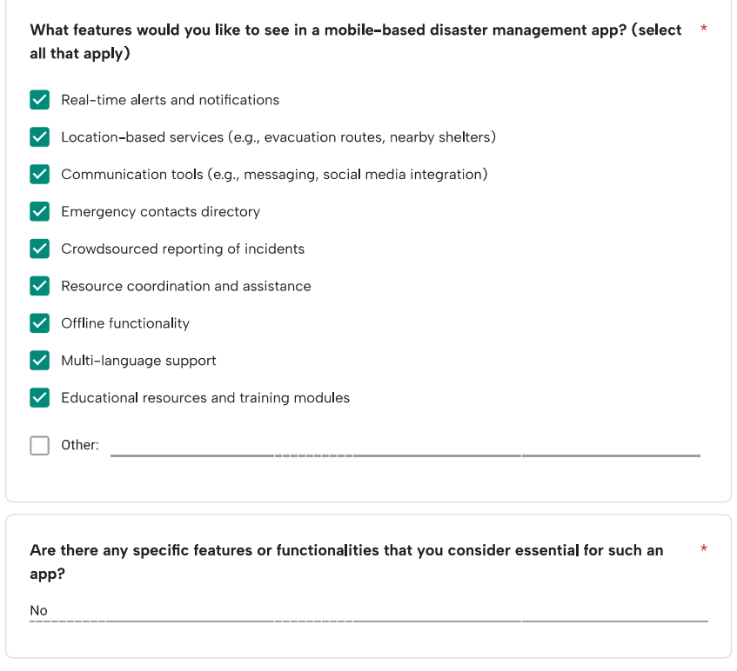

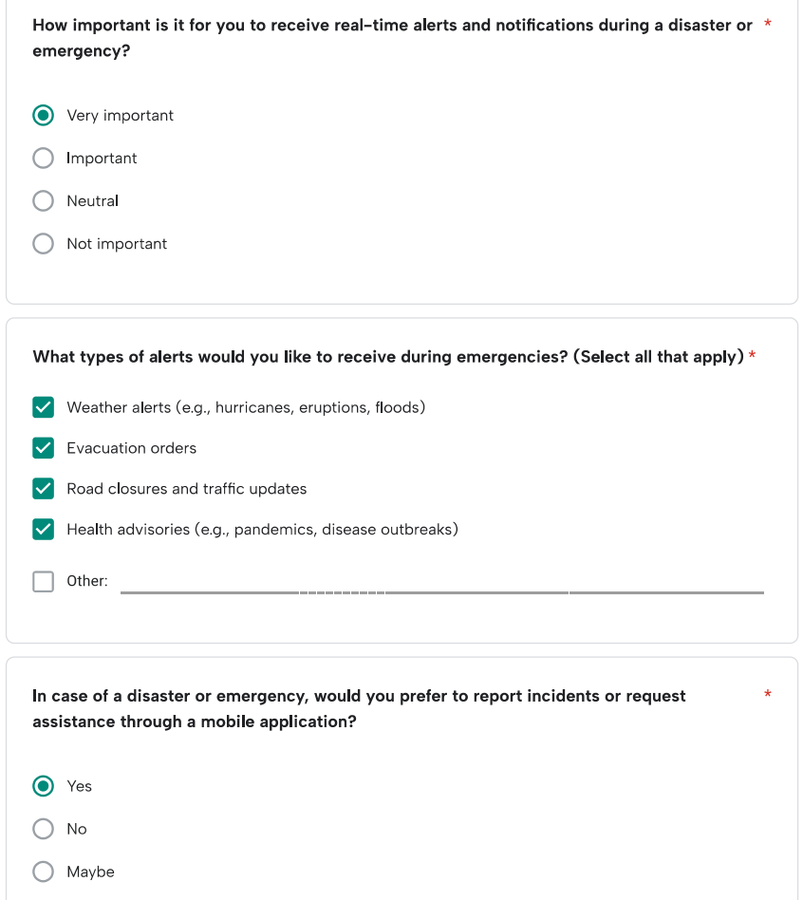

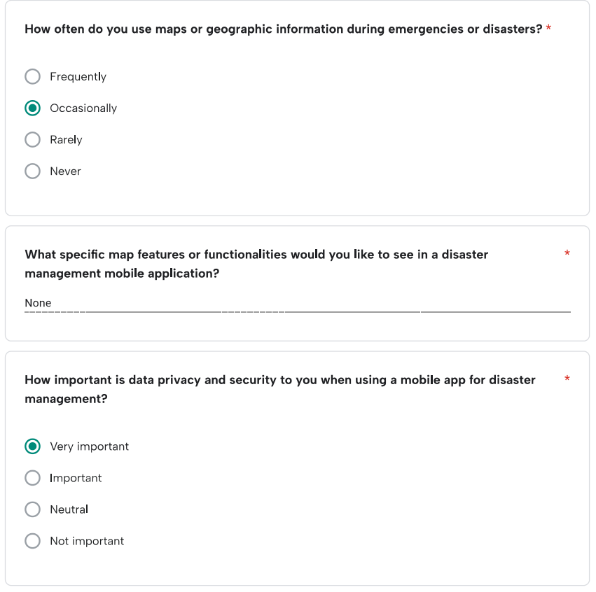

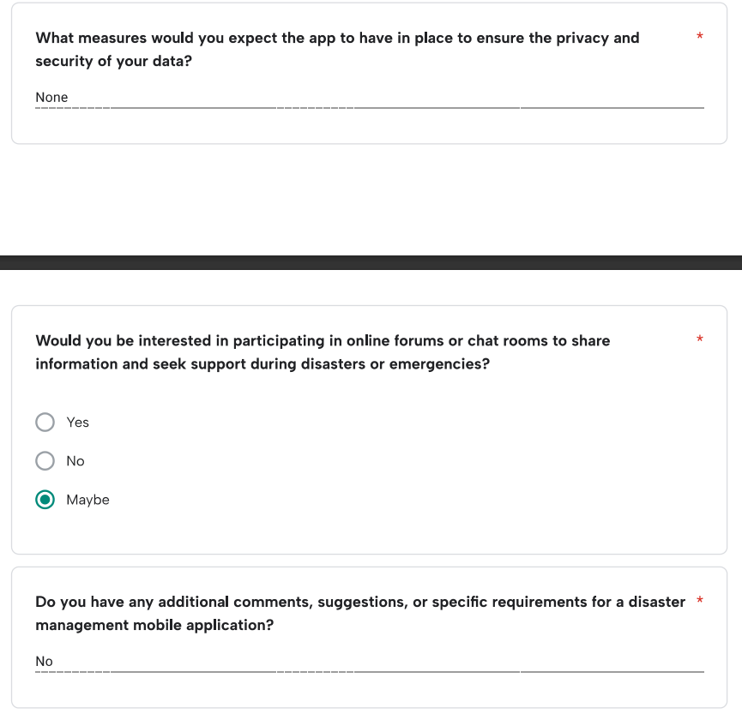

### Response 3:

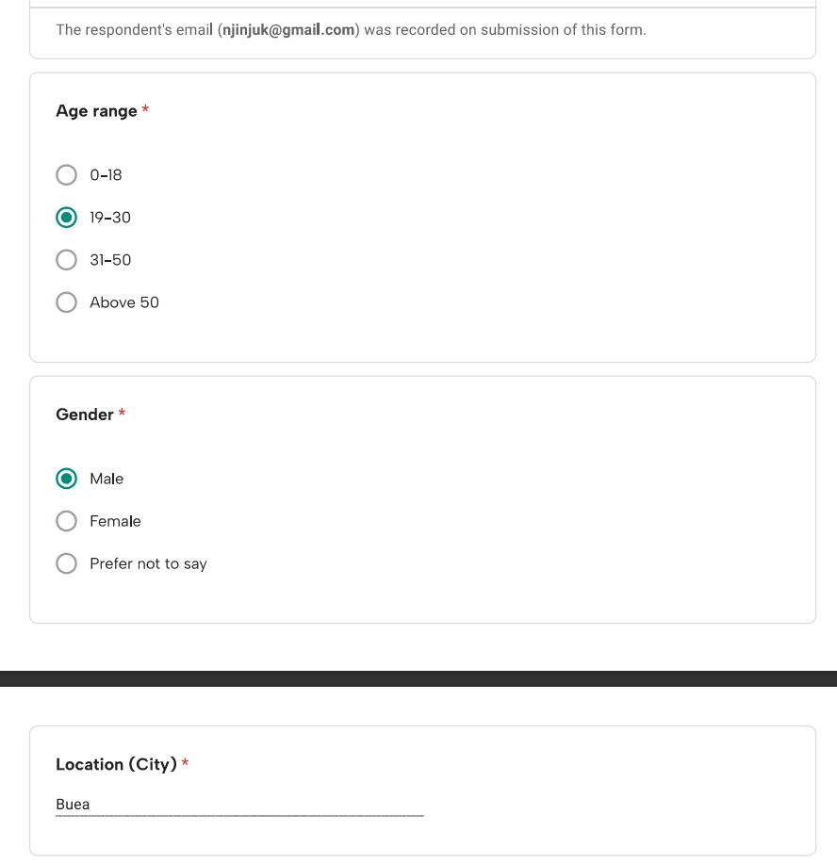

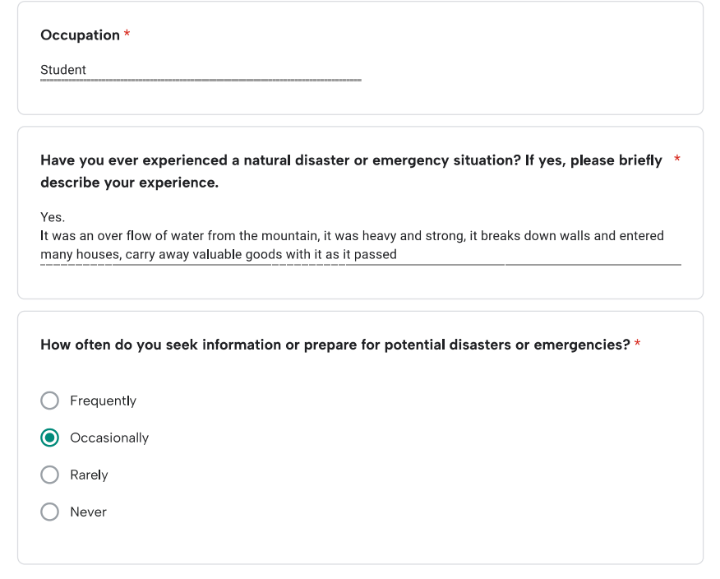

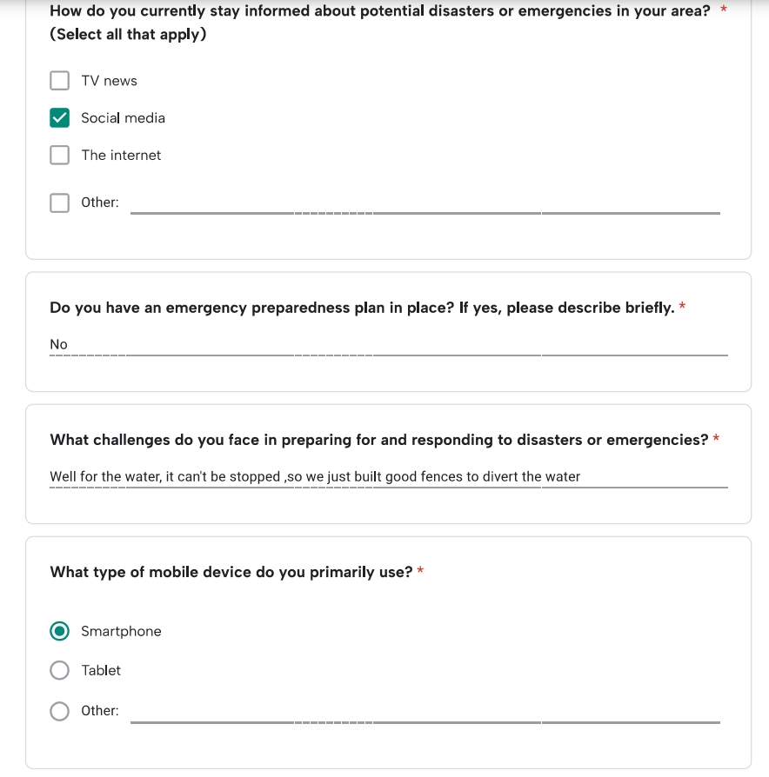

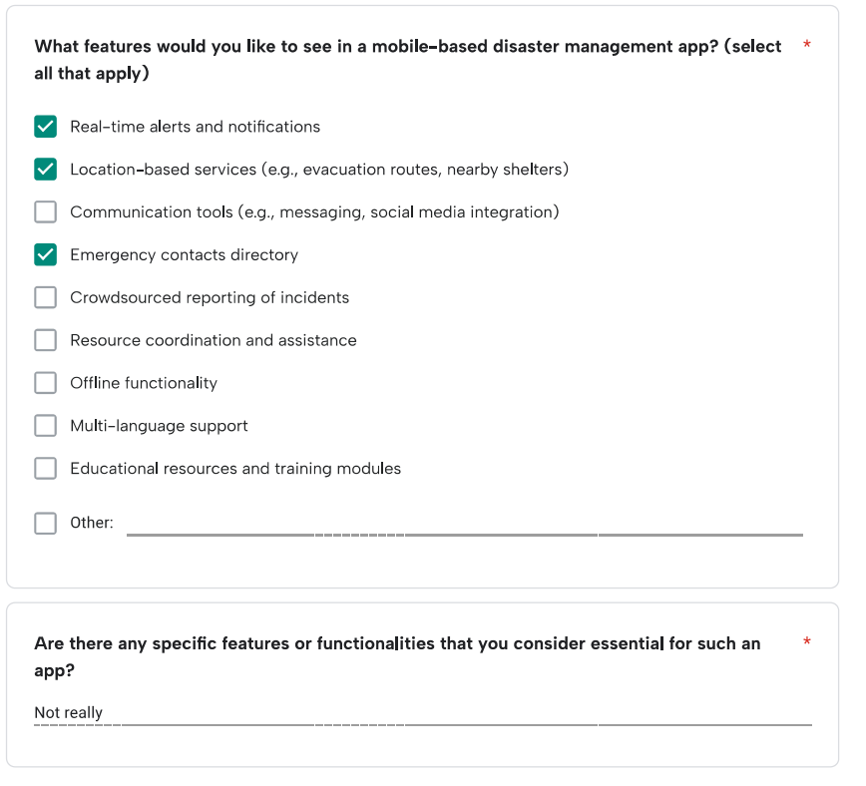

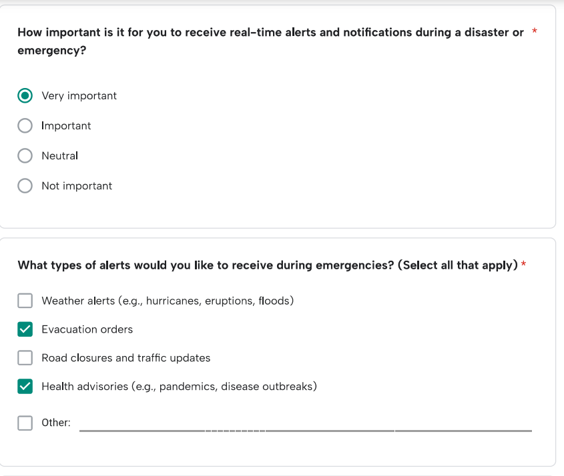

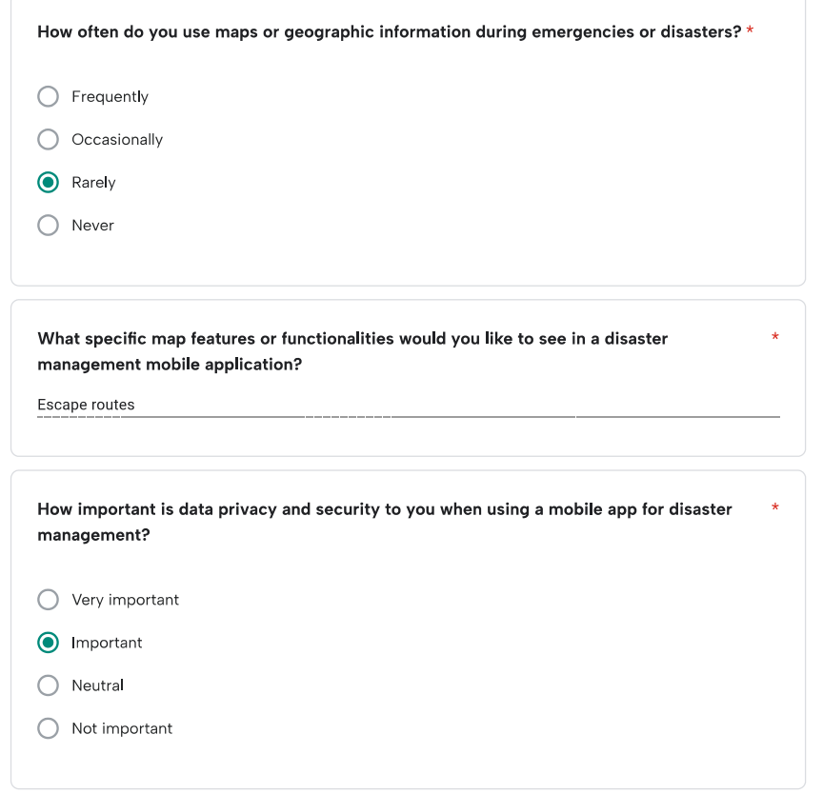

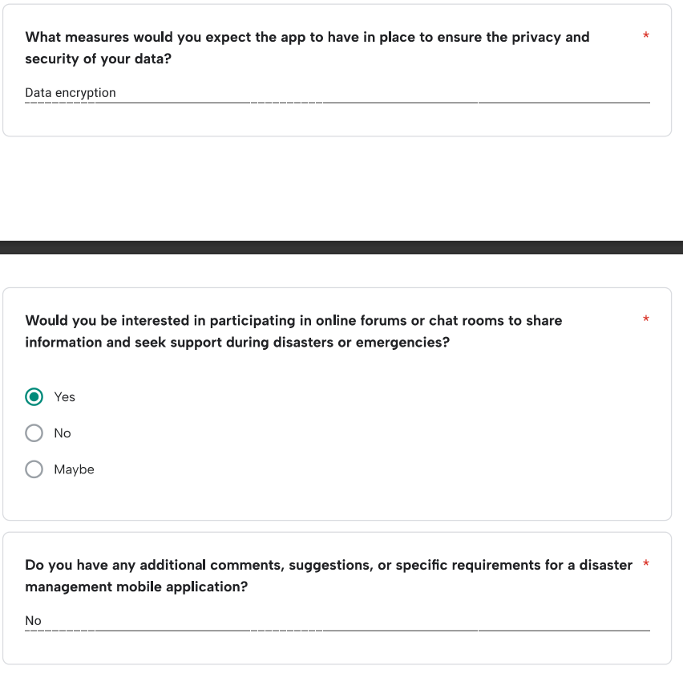

## **Research**

**South West Limbe Flood (July 18-19, 2023)**

In July 2023, the South West Limbe region experienced a catastrophic flood triggered by continuous heavy rainfall, resulting in widespread devastation. The deluge inundated communities in Church Street, Mawoh, and Down Beach, affecting approximately 1600 individuals. The primary causes of this disaster included the unchecked run-off water exacerbated by unplanned construction, which impeded natural water circulation. Collateral damages were significant, with shops destroyed and buildings damaged.

**Buea Flash Flood (March 18, 2023)**

Torrential rains in Buea on March 18, 2023, led to intensive flash floods and mudslides, devastating communities in the South-West region. Originating from Mt. Cameroon, the floods claimed lives, hospitalized several individuals, and left many missing. An estimated 3000 people were affected, with widespread collateral damages including the loss of livelihoods, livestock, and crops. Additionally, the destruction of water catchment and supply infrastructure exacerbated the impact of the disaster.

**Makepe Missoke Flood (August 21, 2020)**

In August 2020, Douala's densely populated Makepe Missoke neighborhood faced a devastating flood, stemming from a combination of factors including rapid urbanization, poor planning, and geographical predisposition. The flood engulfed approximately 2210 buildings and displaced over 12,000 individuals across 82 hectares. To mitigate future risks, efforts were made to develop a model for classifying flood risks and conducting simulations to provide detailed information on flood characteristics.

**Bamenda Market Fire (February 2024)**

In February 2024, Bamenda's main market, the largest in the North West region, was engulfed in a devastating fire, resulting in extensive damage. The inferno destroyed close to 300 shops, causing significant economic losses estimated in billions of CFA francs. In response to the disaster, community leaders and government figures launched a fundraising campaign, collecting 43 million FCFA to support recovery efforts.